23/10/2025 — Making the model actually appear
Goal for this sprint
We focused on the moment between “Model ready” and seeing the model on the page. The pipeline reliably creates and loads the GLB, but in several runs the model was created and loaded yet not shown. Today was about proving what’s happening, tightening the attach step, and documenting the exact configuration that makes tracking kick in.
What we verified end-to-end
- Tap Generate → we capture one still of the page (JPG for upload, Texture2D for tracking).
- We create a Meshy job, poll, and receive a GLB URL.
- We download and load the GLB. Logs confirm the GameObject exists (“Model ready”), but we keep it hidden until we can anchor it to a tracked image.
- We wait for ARTrackedImageManager to report the same picture (state=Tracking). Only then should ModelOverlayController parent + scale the model and enable it.
Why the model didn’t show immediately even though it was “ready”
- Tracking needs the same 2D picture back in view. If the camera isn’t looking at the original page (or the picture is too small/at a hard angle), trackedImagesChanged won’t fire for our CurrentRefName, so there’s nothing to attach to.
- Weak or glossy images don’t track. Low contrast, glare and repetitive textures gave us low ARCore scores; those images rarely trigger a lock.
- Hidden-until-anchored by design. We intentionally keep the model inactive to avoid floating meshes. If tracking never locks, the model stays invisible.
- Library binding matters. If the image was added to a different/missing runtime library than the one used by ARTrackedImageManager, tracking events won’t correspond to our CurrentRefName.
What we changed today
- Clearer device-test routine. After “Model ready”, we now explicitly point the camera at the same picture, filling ~40–60% of the screen and avoiding glare.
- Verbose logging. We enabled extra logs in RuntimeImageLibraryController and ModelOverlayController so we can see: CurrentRefName, tracked image names, states, and whether attach was attempted.
- Consistent library wiring. ARTrackedImageManager’s Serialized Library stays None, and the runtime script assigns a MutableRuntimeReferenceImageLibrary at play time. That prevents ARCore’s build step from failing on static libraries and guarantees the reference we add at runtime is the one the tracker uses.
Current scene and component configuration (what we’re running with on device)
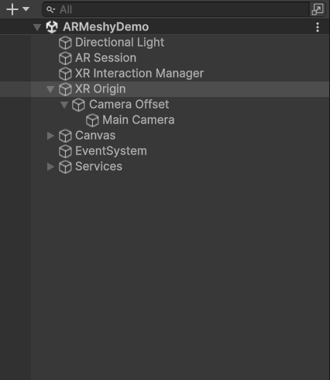
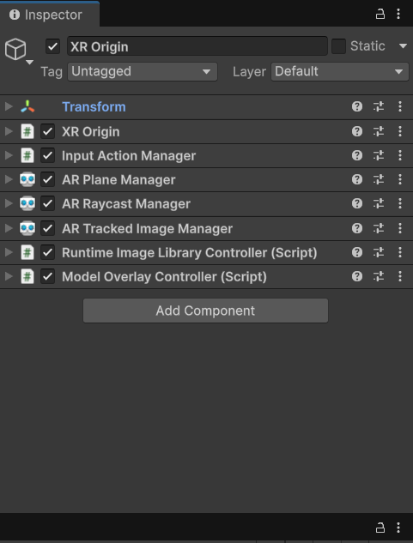
- XR Origin hosts ARTrackedImageManager, AR Raycast/Plane (plane optional), RuntimeImageLibraryController, and ModelOverlayController. (Place screenshot 3 here.)
- In ARTrackedImageManager, Serialized Library = None; Max Number Of Moving Images = 1. RuntimeImageLibraryController points to our empty/base library asset and a default physical width of ~0.15 m. (Place screenshot 4 here.)
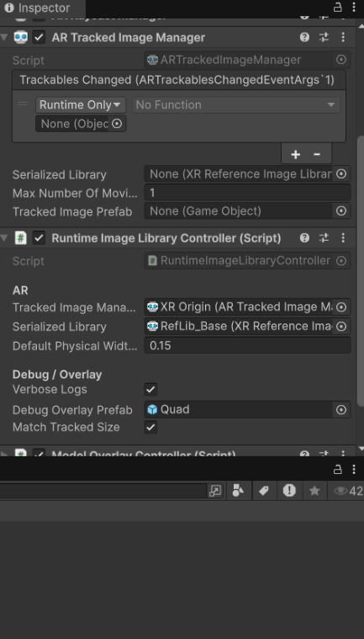
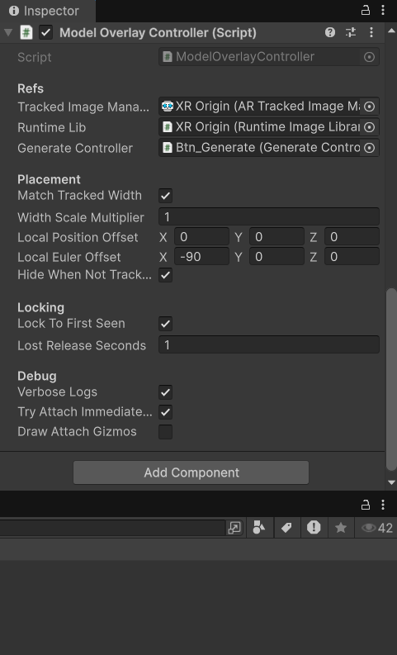
- ModelOverlayController is set to Match Tracked Width, Local Euler Offset X = −90 (so most GLBs stand upright on the page), Hide When Not Tracking = true, and Lock To First Seen = true. Verbose Logs and “Try attach immediately on model load” are enabled while testing. (Place screenshot 5 here.)

- Main Camera has AR Camera Manager + CameraCapture so we get one clean still per run. (If needed, place screenshot 6 here.)
- The Generate button wires to GenerateController with references to UIController, CameraCapture, RuntimeImageLibraryController, ModelOverlayController, MeshyClient, and GltfLoader. (If needed, place screenshot 7 here.)
- The overall scene hierarchy is clean: XR Origin, Canvas (UI), EventSystem, and Services (MeshyClient, GltfLoader). (Place screenshot 2 here to show the simplified hierarchy.)
What we learned from field tests
- The GLB is there. When the log says “Model ready ✓”, the GameObject exists in memory. If you don’t see anything, it’s a tracking/attach issue—either the picture isn’t recognized, or conditions (size, angle, light) aren’t good enough.
- Bigger helps. When the reference picture fills about half the screen, tracking locks much more consistently.
- Clean brightness beats noise. Diffuse light, minimal reflections, and a photo that’s not blurred make a big difference.
Future improvements we want to build next
- Reference snapshot + gallery. Save the exact snapshot we used as the reference and show it in the UI so users know what to aim at after generation. Also let them browse previously generated entries.
- Model cache keyed by image hash. Store a perceptual hash (pHash/aHash) of the reference snapshot and map it to the produced GLB. If someone scans the same picture later, skip generation and fetch the cached model instantly.
- AI-driven sound on top. Run a lightweight classifier (or use the generation prompt labels) to detect the animal type from the snapshot, fetch the matching sound from an audio API, and play it when the model appears.
- Local/offline reuse. Keep recent GLBs and thumbnails on device with versioning and size limits.
- Fallback placement mode. If image tracking is weak, allow a tap-to-place as a temporary fallback so users can still play.
- Robust attach heuristics. If the model is loaded and the last seen tracked image already matches CurrentRefName, auto-attach without waiting for another event; if tracking is lost, gently fade the model rather than hard-hide.

